# Detailed NIC and EC2 After launch Features



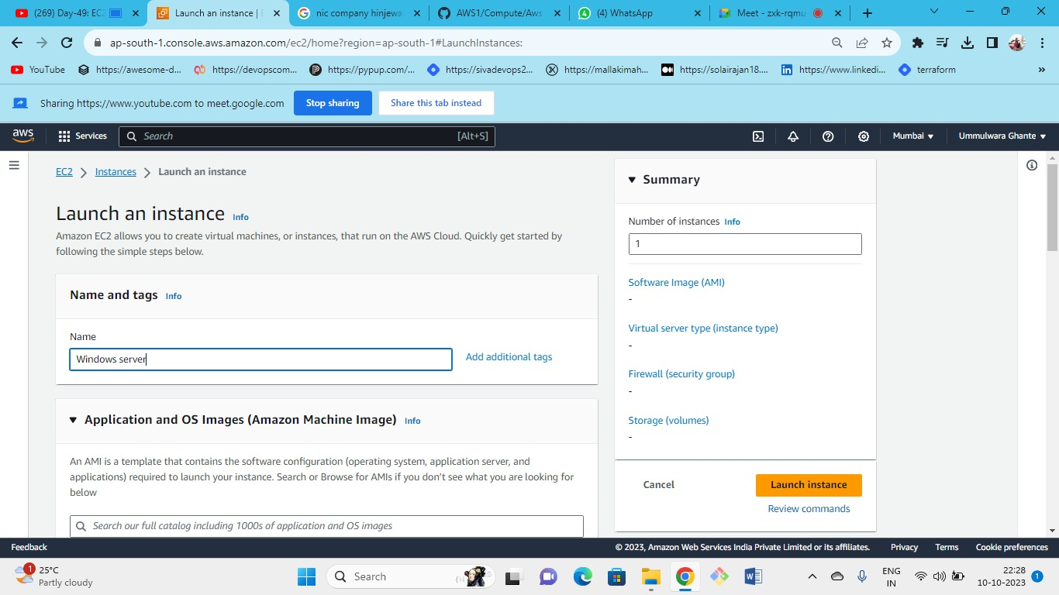



OS (windows)--->instance type(t2.micr0)---> keypair(create new or keep old one)--->security group (new or existing)-->storage(gp3)--->launch.

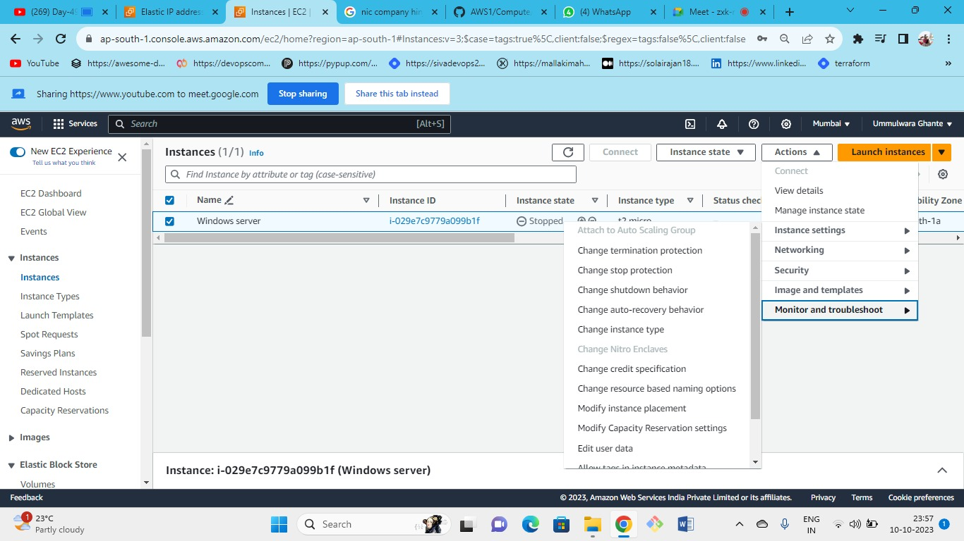



When the instance is in stopped state then we can change the following settings.

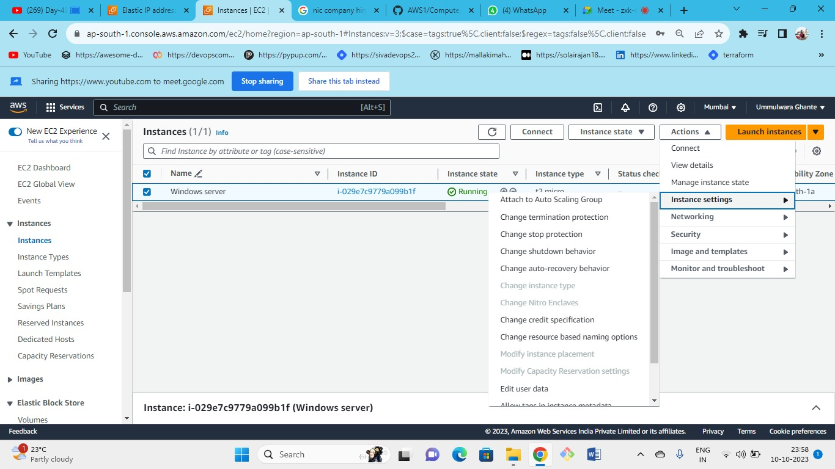



Stop the ec2 instance -->action-->instance settings--> change instance type.

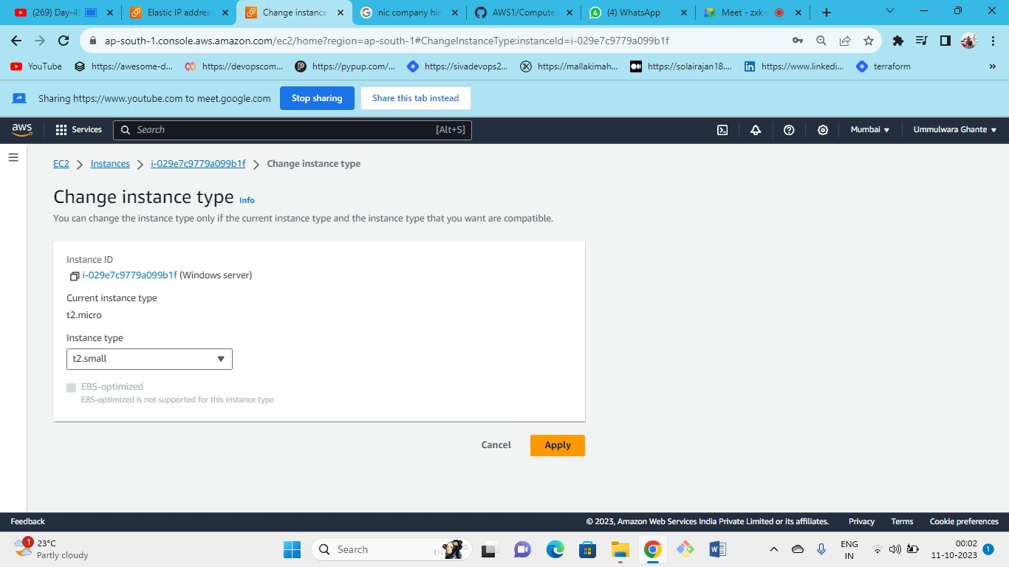



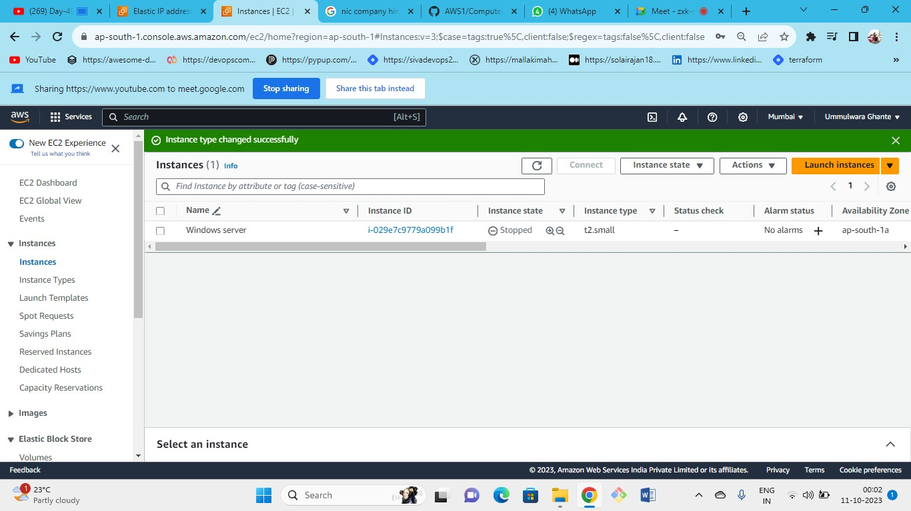



As we can see our instance type has been changed from t2 micro 🡪 t2 small.

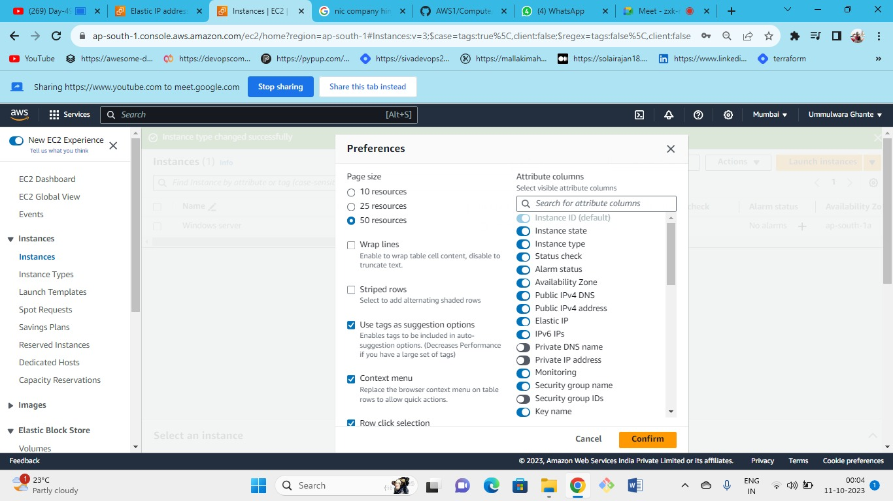



* Different types of ec2 will have different credit specification
* Limited credit specification:
* The t2 family is the burstable family and has limited credits. We will get these credits for 12 to 24 hours to be credited to our account.
* When these credits are utilized then the CPU will not be burstable
* CPU will not be burstable anymore in limited credits
* In unlimited credit specification
* If we have unlimited CPU usage whenever the baseline exceeds this CPU will burst out, and then you need to pay charges for the no of credits you use.
* If you cross the limit of CPU baseline within 24hrs then you need to pay the charges.

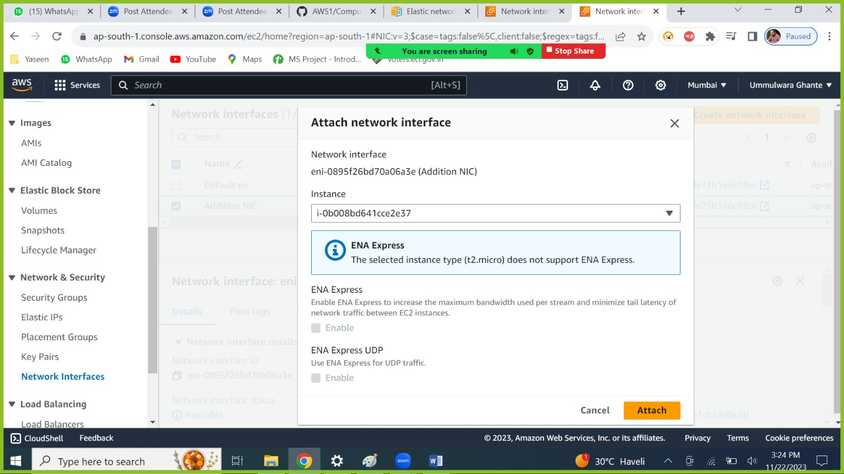



* As we have one server and we have created NIC (default+ additional) that is why we can see 2 private IPs in the next image.
* As we cannot see public IP because – we have created one additional NIC and in that we have allocated one elastic IP.
* That is why we cannot see Public IP as well as elastic IP
* Even though we have attached elastic IP to additional NIC it will not be visible in the I instance summary as it will only show Public IP of default NIC (but additional NIC public IP (i.e., elastic) will be present in NIC list)

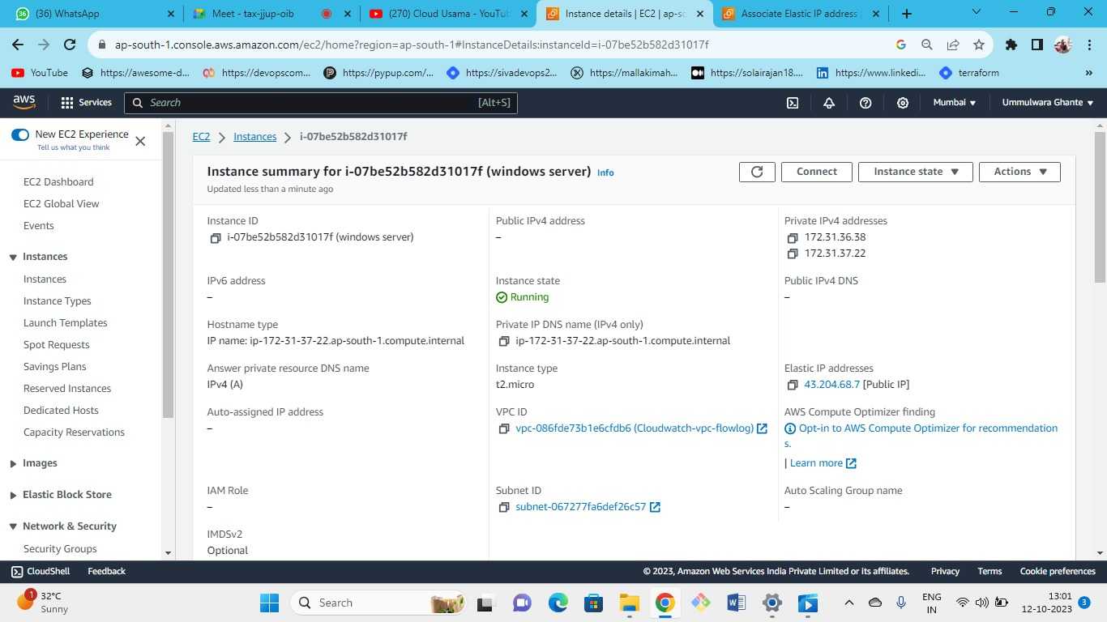



* As you have stopped and started the instance AWS will take your public IP of default NIC .
* as we have created one elastic IP for an additional NIC so AWS will treat that EIP as a public IP (but it will not be visible in the instance summary) on the windows.
* One server will have only one public IP or elastic IP but can have multiple private IP’s.
* Note – you cannot have an EIP and public IP address at the same time (when we have default NIC we get aws allocated public IP but if create and associate elastic IP to default NIC then AWS associated public IP is replaced by the Elastic IP which we have created).

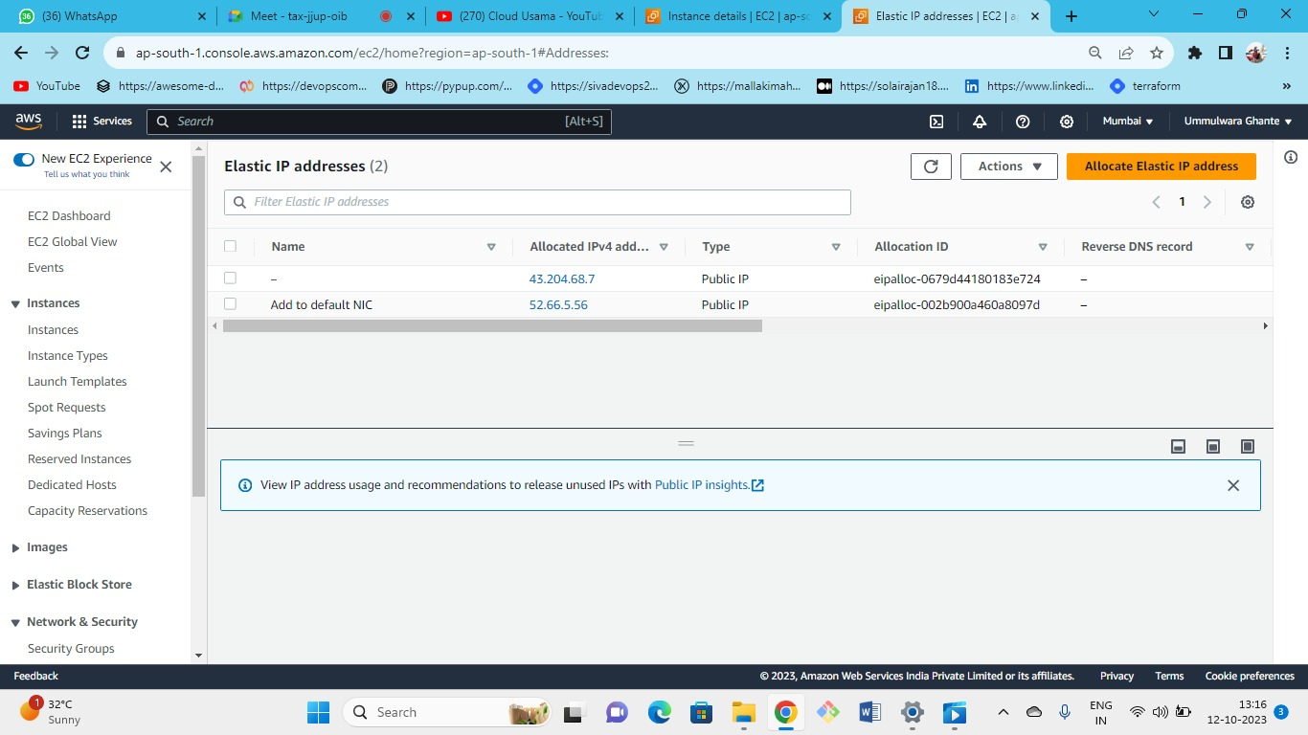



Now associate this elastic IP to the NIC.

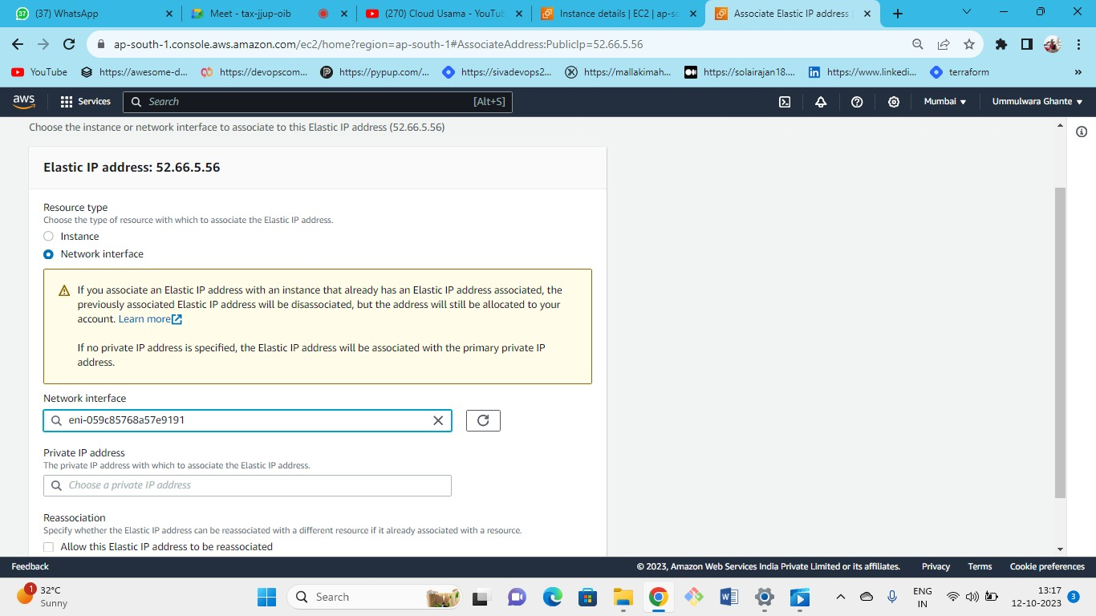



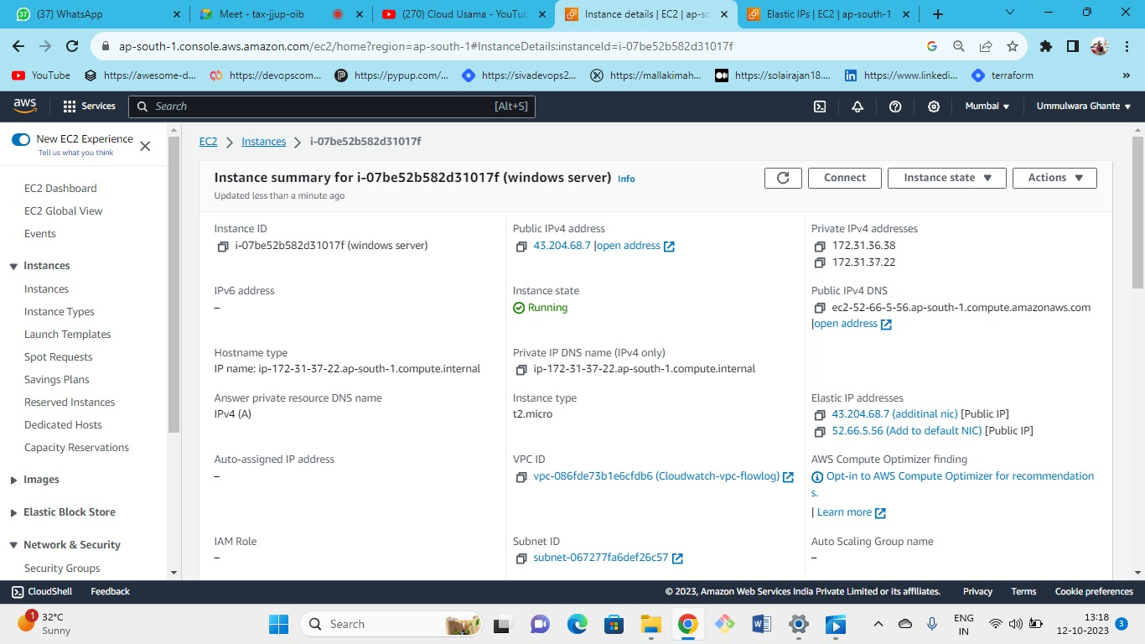



As we can see elastic IP is allocated as public IP

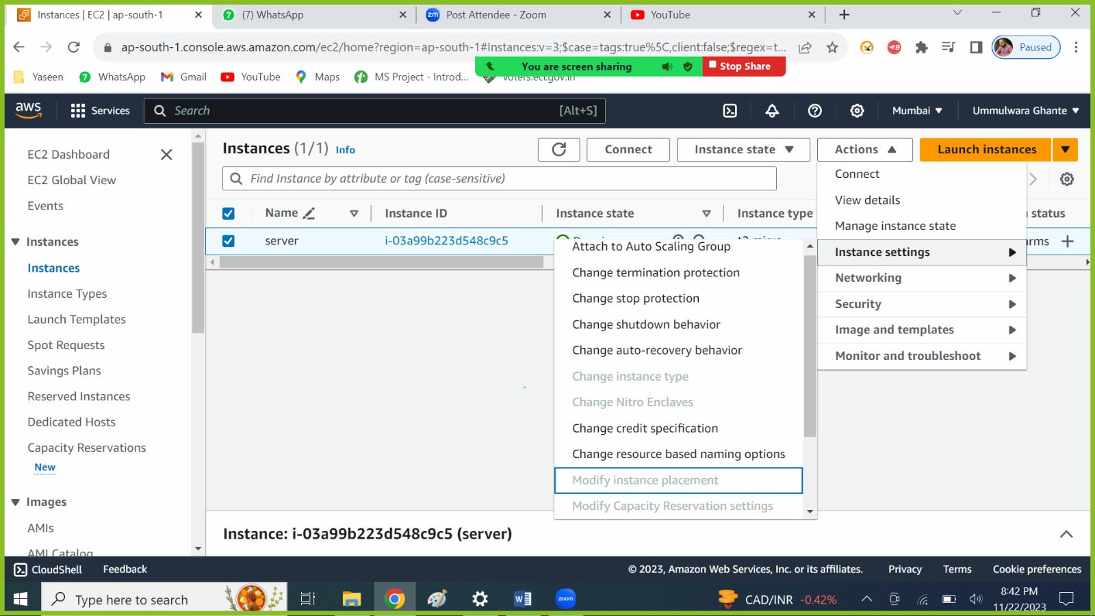



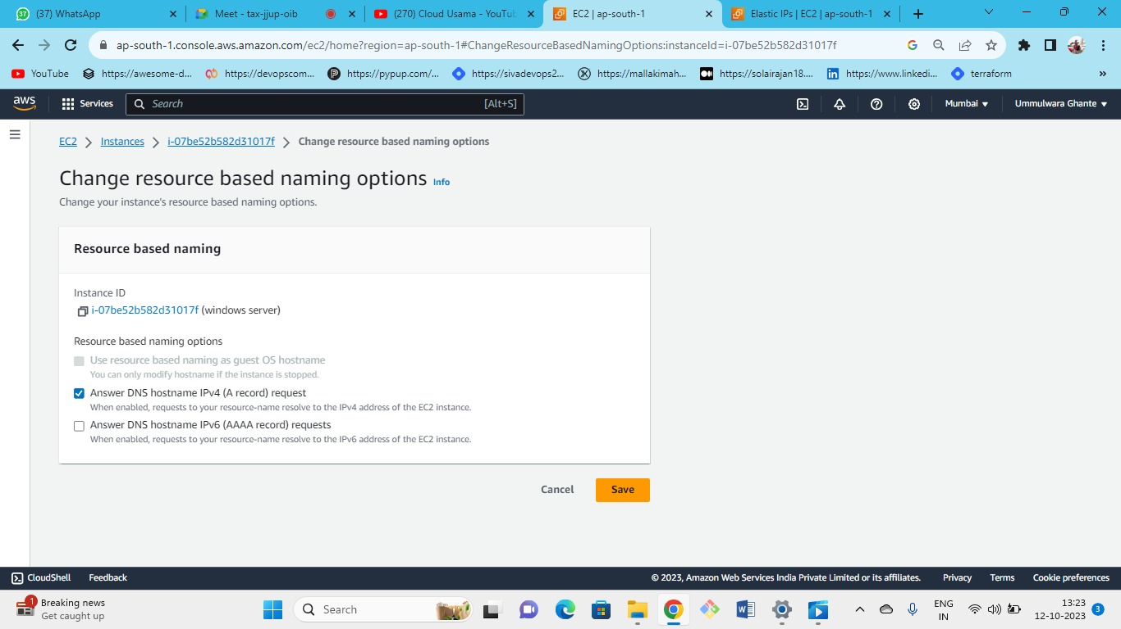



Instead of DNS, we can have our own resource name (i.e., domain name).

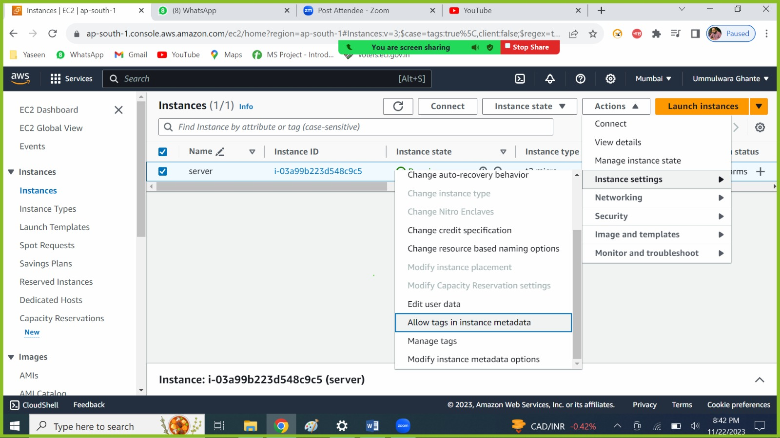



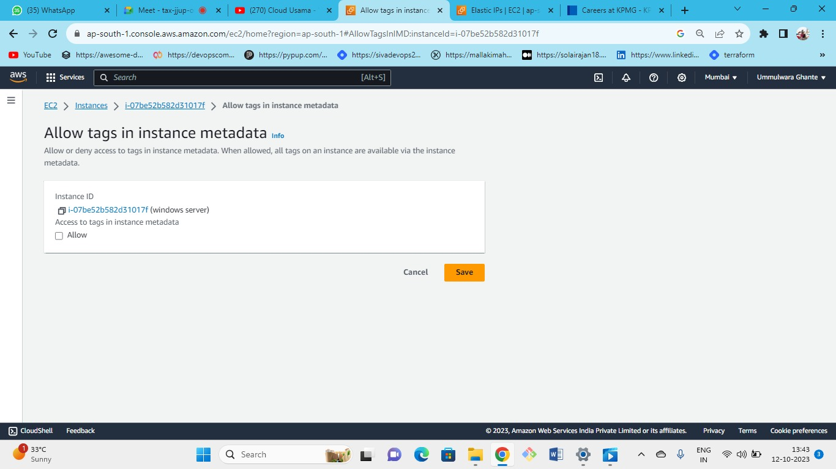



* By allowing these tags will be considered as metadata in instance.
* all the tags which are attached to instance will be used as meta-data
* information about resource: metadata

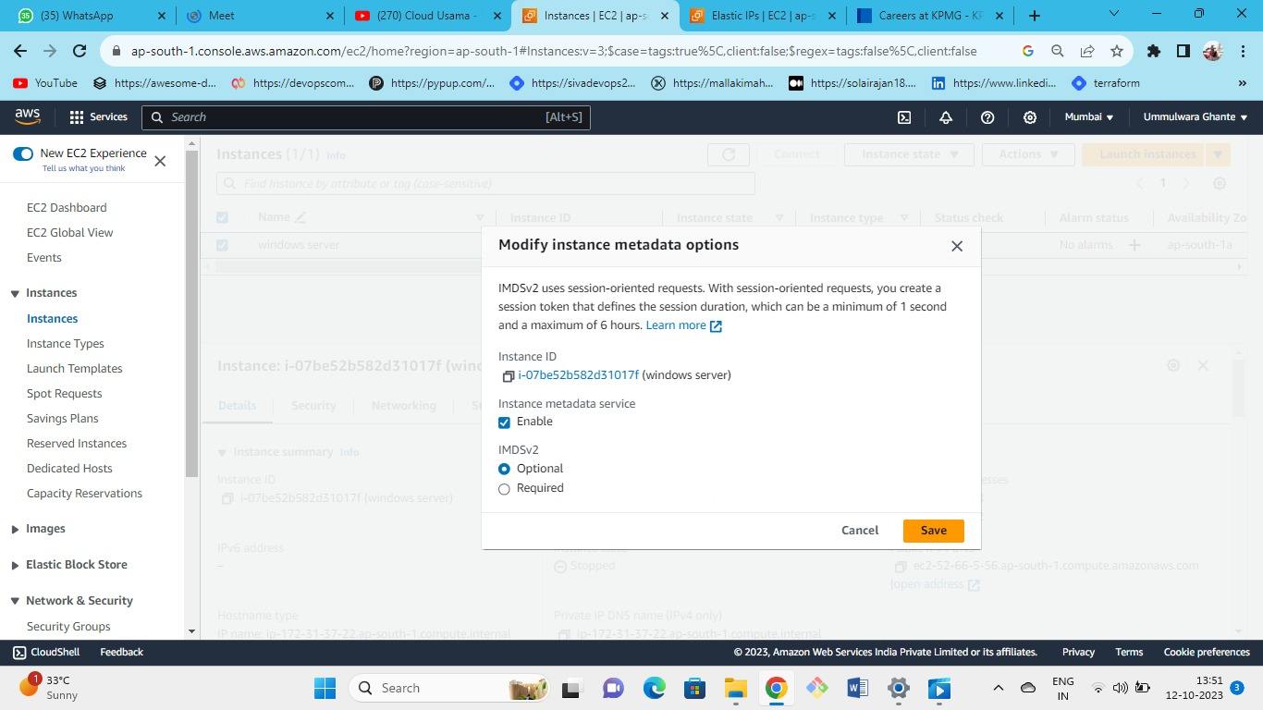



To check the metadata

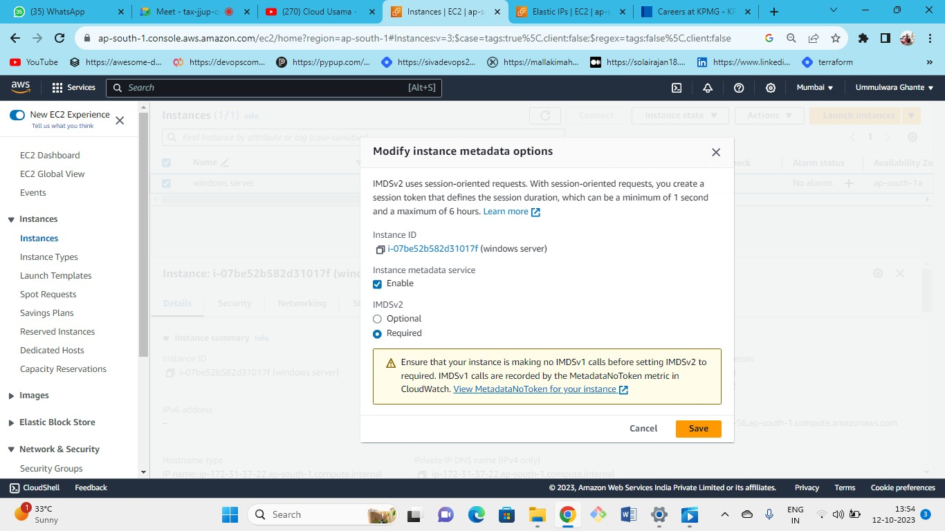



Lauch one Linux server

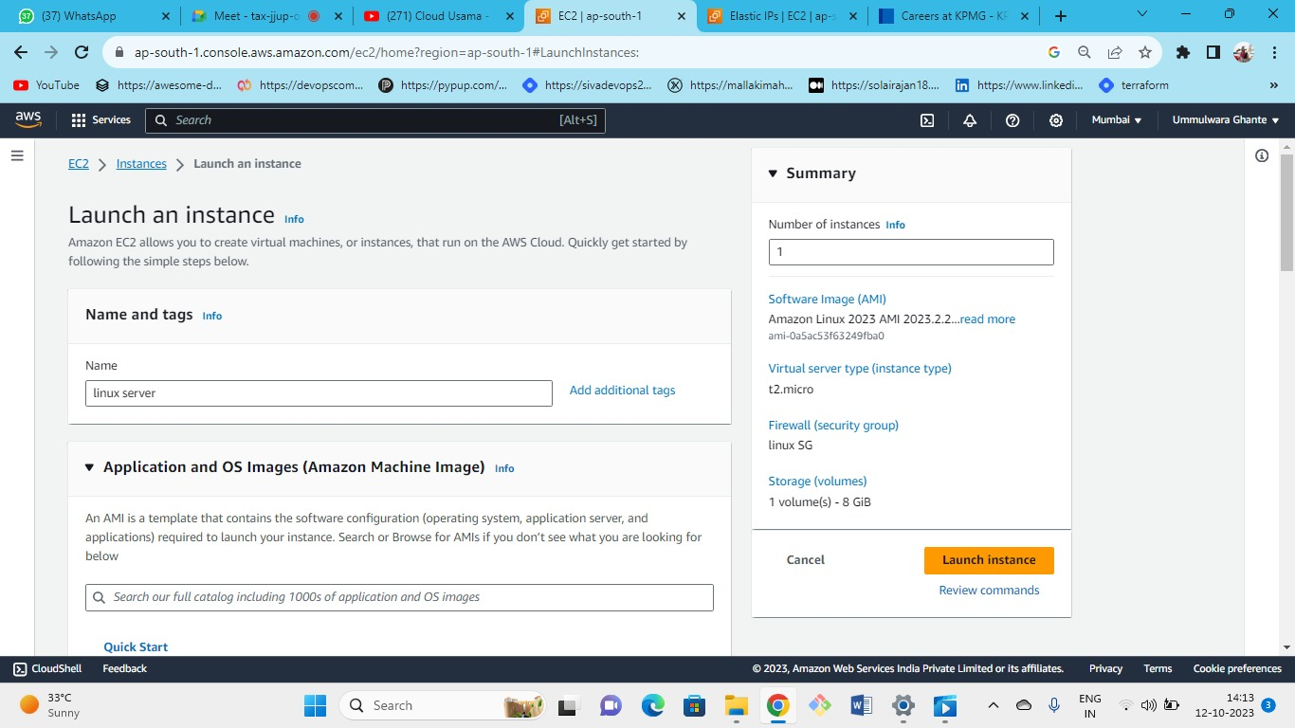OS (Linux)--->instance type(t2.micr0)--->keypair(create new or keep old one)--->security group (new or existing)-->storage(gp3)--->launch.



**Commands to check metadata**

* To view all categories of instance metadata from within a running instance, use the following IPv4 or IPv6 URIs.
* For Windows
* IPv4
* http://169.254.169.254/latest/meta-data/
* IPv6
* http://[fd00:ec2::254]/latest/meta-data/
* For Linux (IMDSV1)
* curl <http://169.254.169.254/latest/meta-data/>
* IMDSV2
* TOKEN=`curl -X PUT "http://169.254.169.254/latest/api/token" -H "X-aws-ec2-metadata-token-ttl-seconds: 21600"` \
* && curl -H "X-aws-ec2-metadata-token: $TOKEN" -v <http://169.254.169.254/latest/meta-data/>

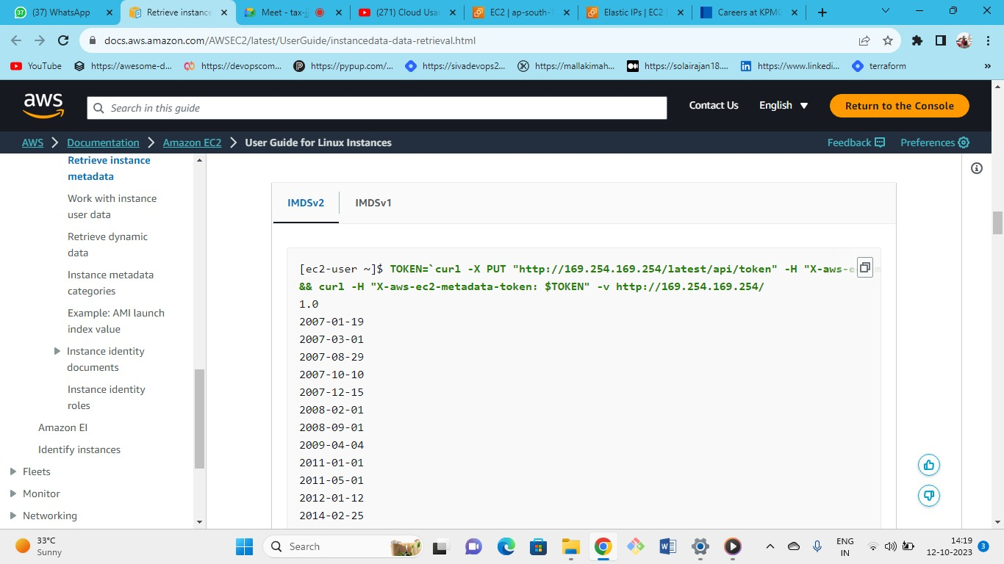

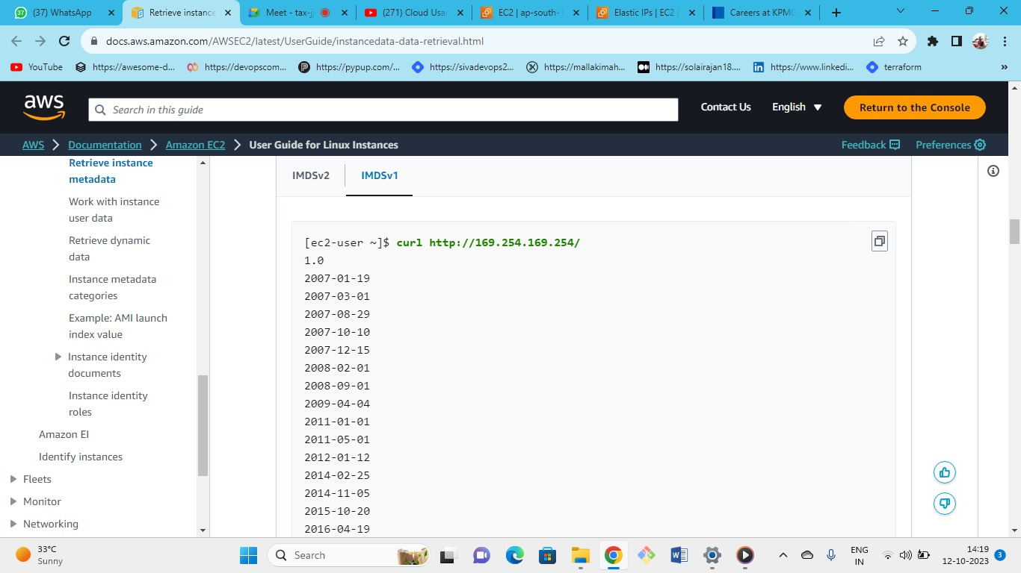

Now connect your Linux instance by instance connect

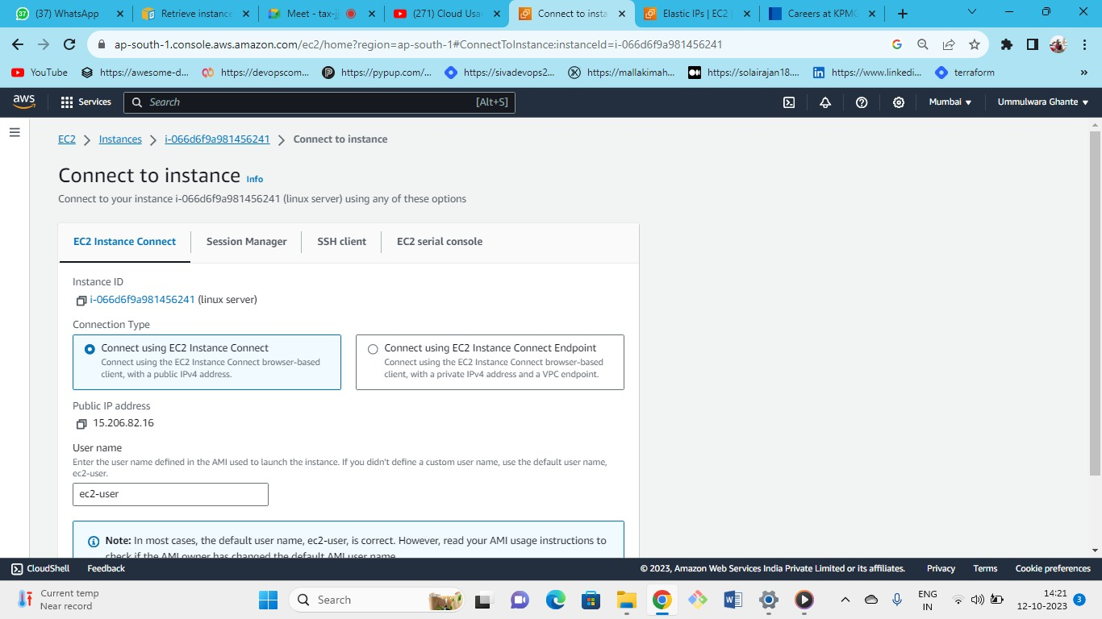



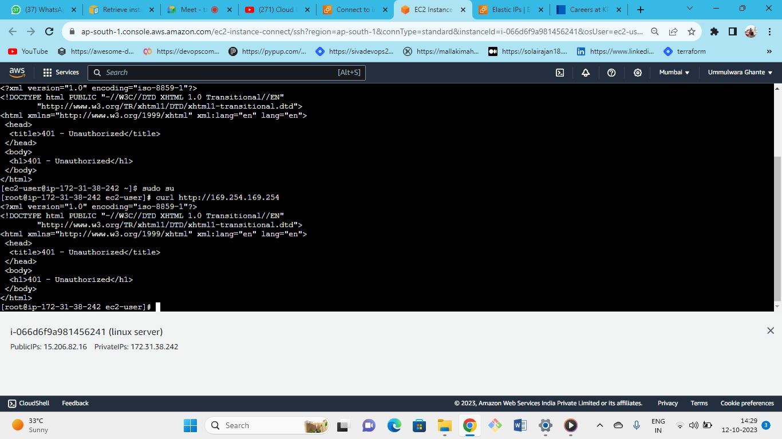



By putting the commands of Linux as it is unauthorised because of (required)

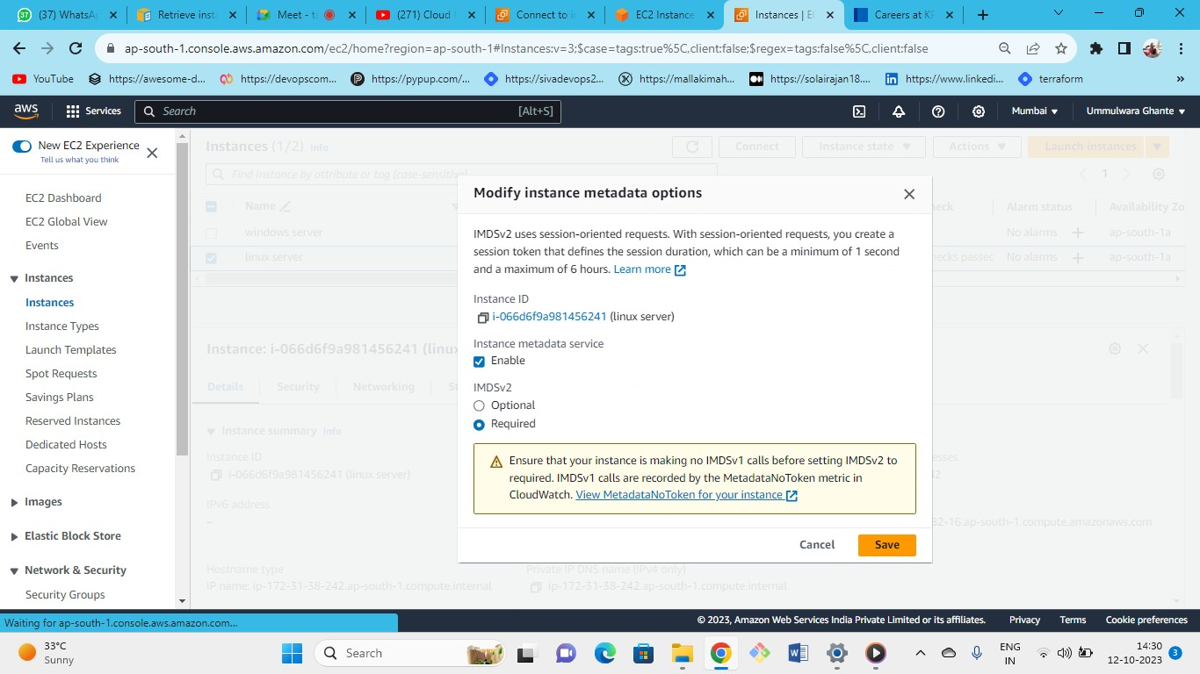



Set it to optional

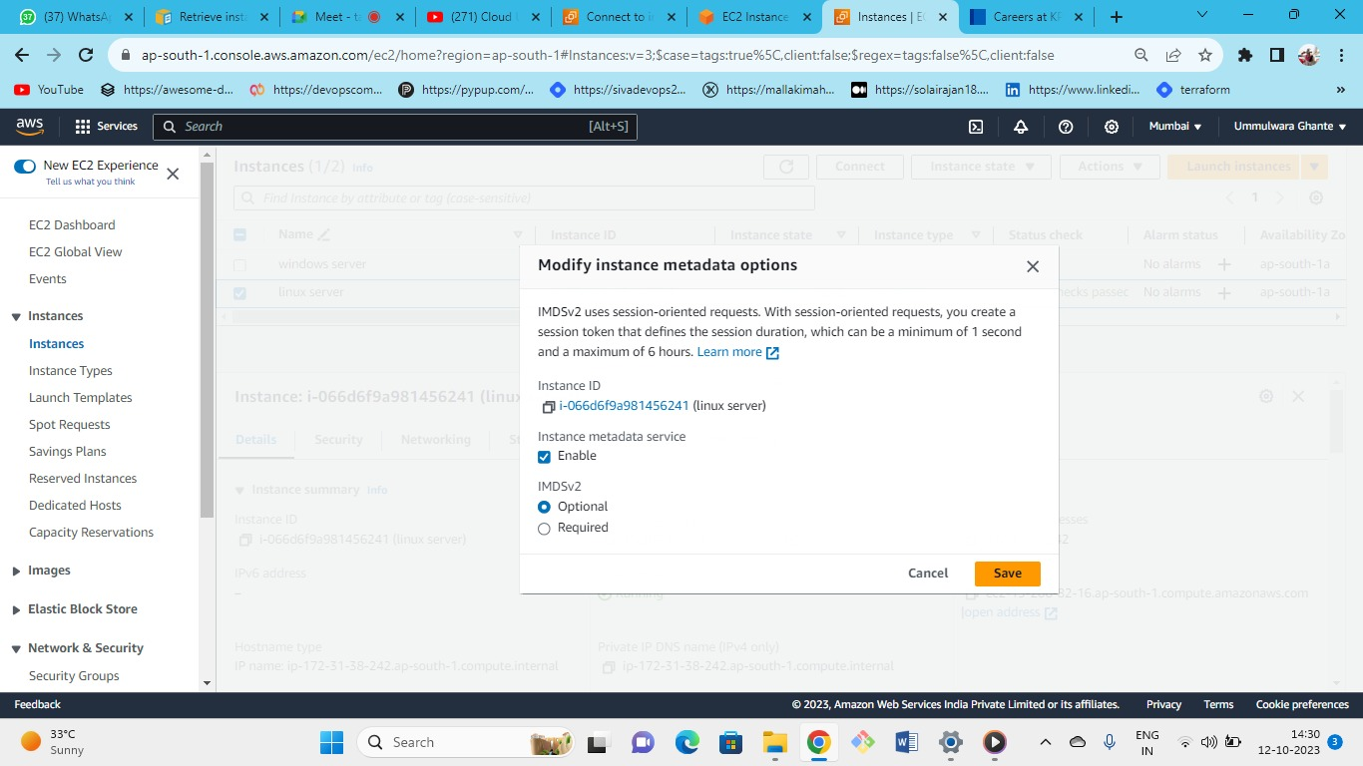



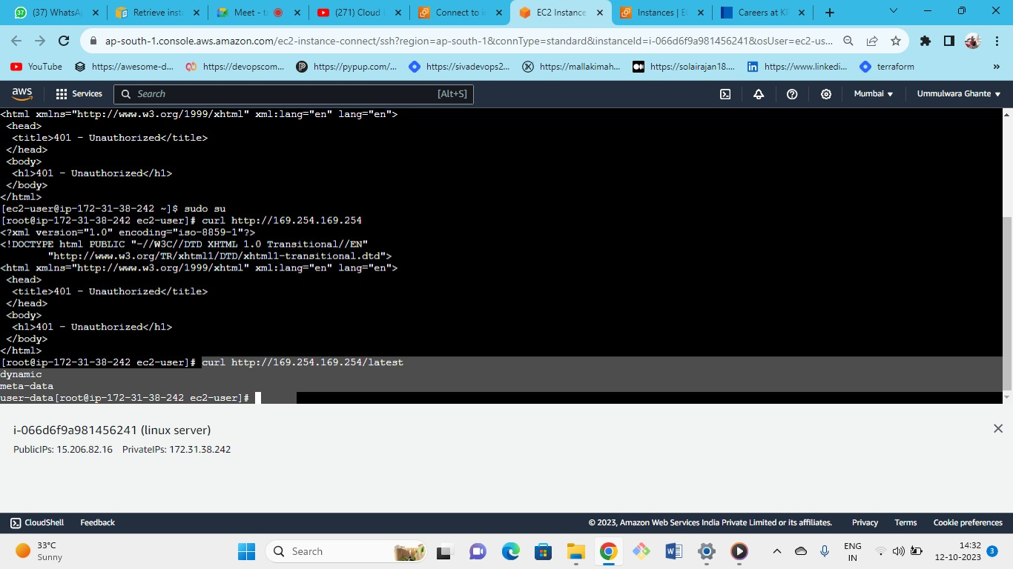



To see the meta-data

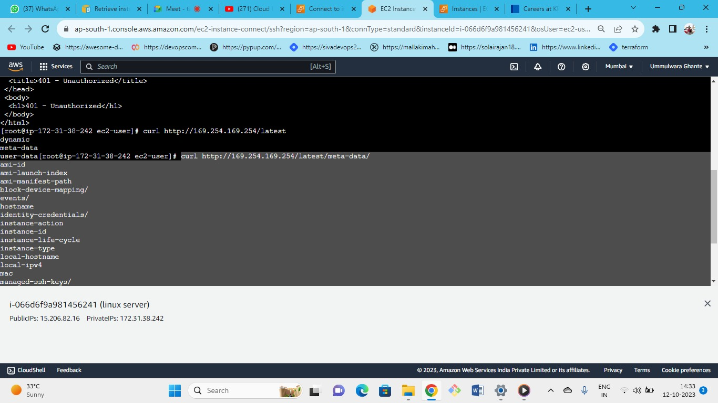



As we can see that all the meta-data is present of instance

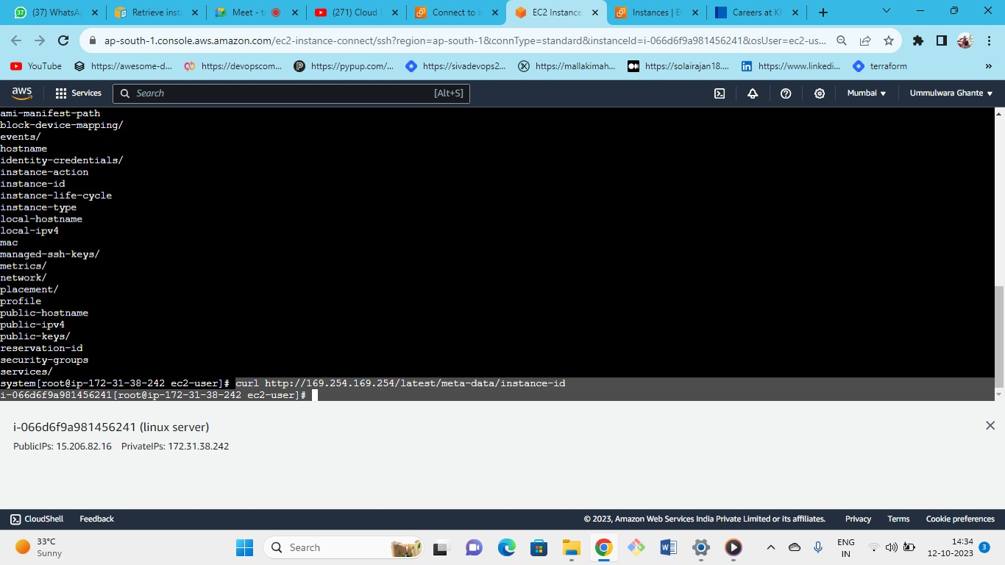



if you need only instance id then

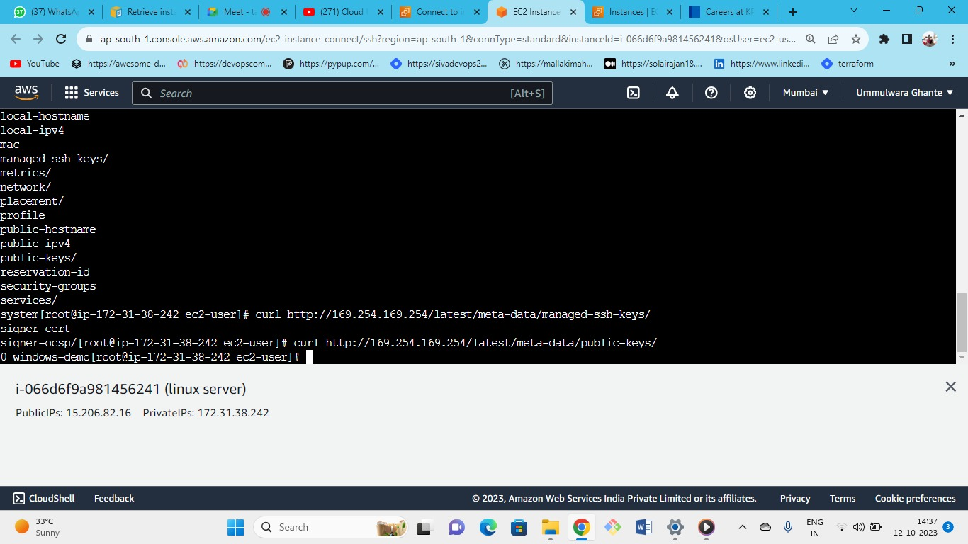



If you want to see the SSH Keys and Public Keys of your instance

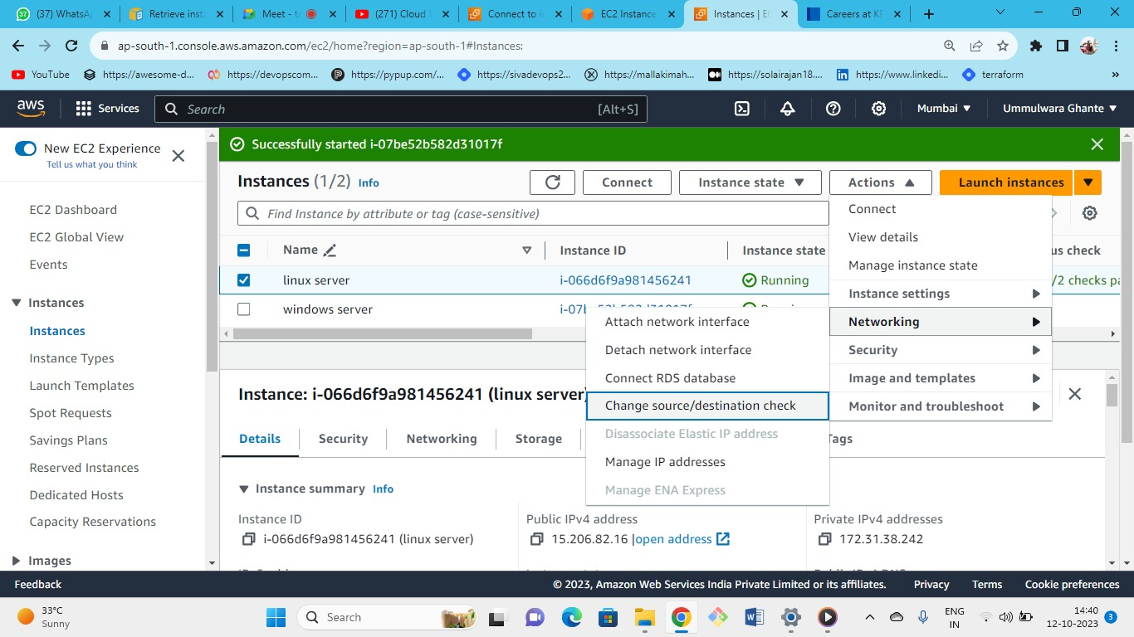



you have all these options

**if you need to use this server as NAT gateway then in that case you disable this.**

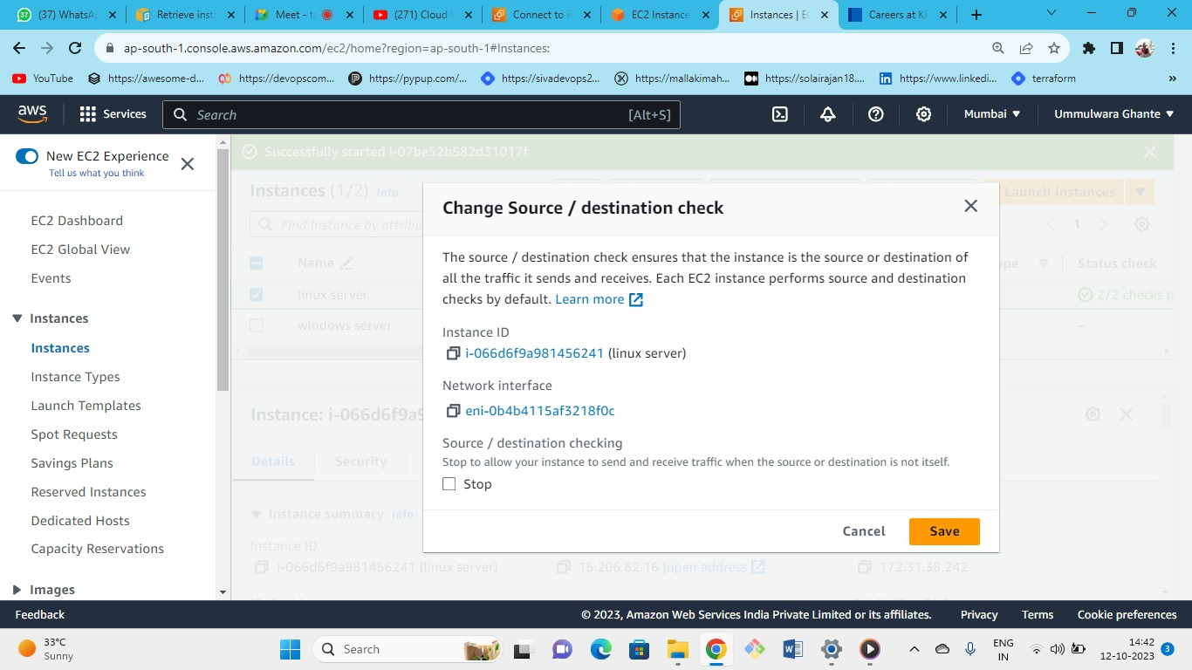



In windows server as we have 2 NIC we can detach one NIC by using following option

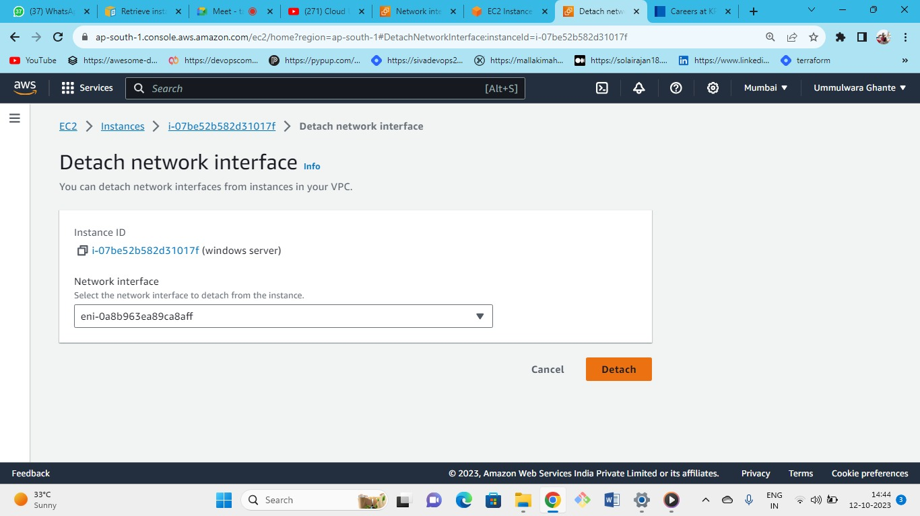



You can attach or detach the NIC according to you when the instance is in running state.

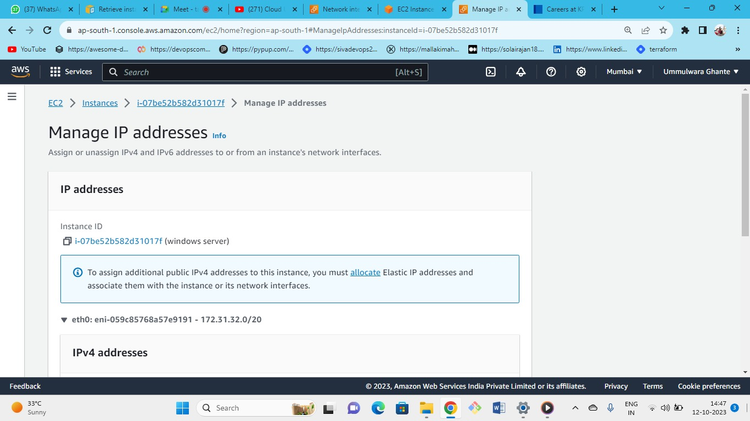



you can attach multiple private IP address per NIC

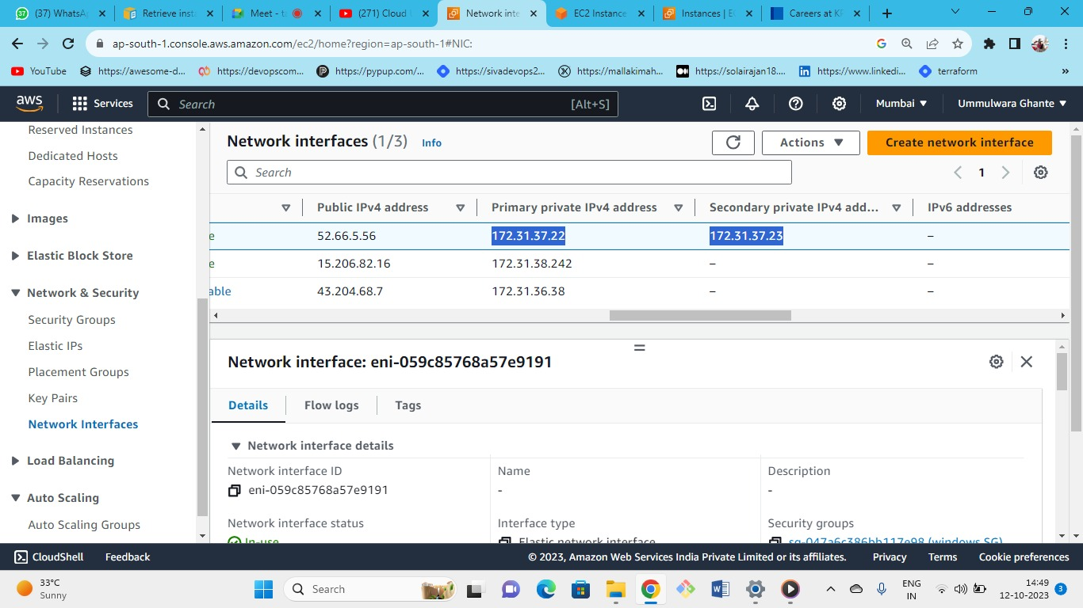



As we can see we have attached secondary private IP to our NIC

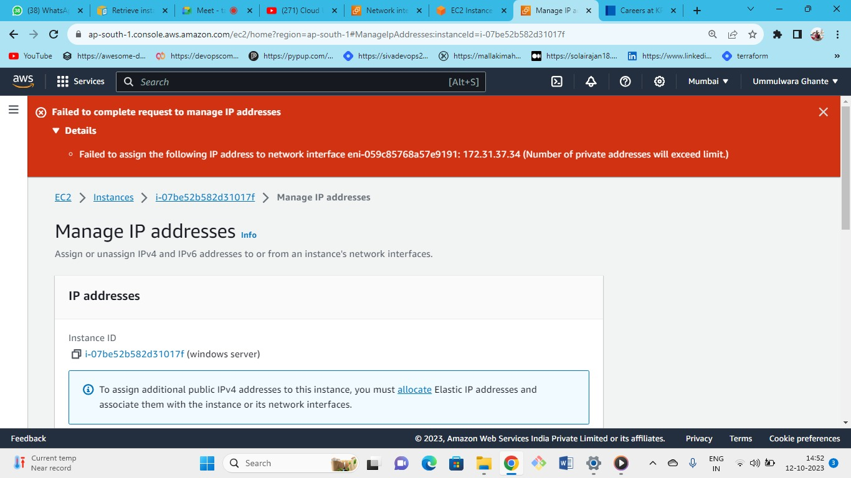



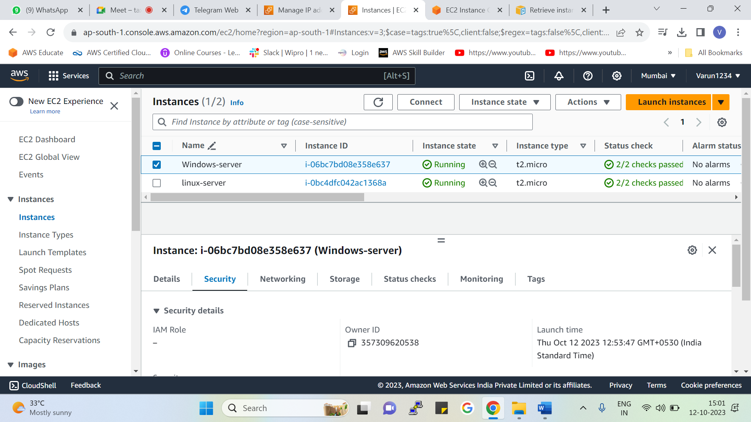



As you can see we don’t have any IAM roles attached

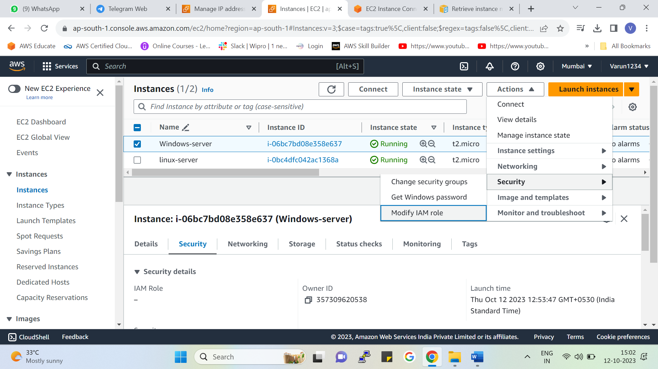



Select instance 🡪 actions 🡪 security 🡪modify IAM (from here you can change your IAM role)

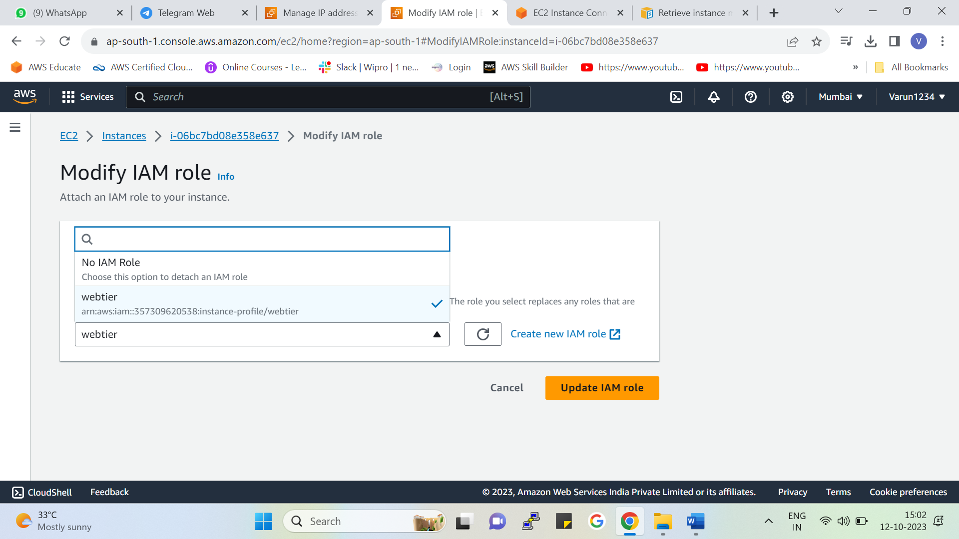



* Can choose the IAM role
* Note – after attaching to detach role we need to select no IAM role
* **We can only attach one IAM role per EC2 instance**
* **You can also create new IAM Role**